St. Francis Institute of Technology, Mumbai-400 103

**Department Of Information Technology**

A.Y. 2024-2025

Class: TE-ITA/B, Semester: V

Subject: **DevOps Lab**

**Experiment – 10: To learn Pull based Software Configuration Management and provisioning tools using Puppet.**

1. **Aim:** To install and Configure Pull based Software Configuration Management and provisioning tools using Puppet.
2. **Objectives:** Aim of this experiment is that, the students will learn:

* To Synthesize software configuration and provisioning using Puppet
* To Build and operate a scalable automation system.

1. **Outcomes:** After study of this experiment, the students will learn following:

* Architecture of Puppet
* Puppet Master Slave Communication
* Configuring Puppet Master and Agent on Linux machines

1. **Prerequisite:** None
2. **Requirements:** AWS account,putty, Personal Computer, Windows operating system, Internet Connection, Microsoft Word.
3. **Pre-Experiment Exercise:**

**Brief Theory:** Refer shared material

1. **Laboratory Exercise**
   * + 1. **Procedure:**

**a. Answer the following:**

* What is Puppet? Enlist its features.
* Explain architecture of Puppet with a diagram.

**b**. **Refer the shared material and do online research to answer following:**

i. Mention steps for creating 2 EC2 instances with Ubuntu OS on AWS for creating master and slave machines. Attach screenshots for the same.

ii. Commands used to configure master and slave machines using putty.

**Commands to run on puppet Master (which is one of the EC2 instances)**

* sudo apt-get update :This command will update the packages
* wget <https://apt.puppetlabs.com/puppet-release-bionic.deb> :This command will download the puppet folder
* sudo dpkg -i puppet-release-bionic.deb :This command will unzip the puppet folder
* sudo apt-get install puppetmaster : This command will install the puppet master
* apt policy puppetmaster : This command will verify puppet master after installation
* sudo systemctl status puppet-master.service: This command will check status of puppet master service
* sudo nano /etc/default/puppet-master: This command will fine tune some settings….
* Add this line in the puppet master file: JAVA_ARGS=“-Xms512m - Xmx512m”

This command will change the memory allocation to 512MB

* sudo systemctl restart puppet-master.service : This command will restart puppet master after the recent changes
* sudo ufw allow 8140/tcp : This command will open TCP port for puppet to communicate
* sudo nano /etc/hosts : This command will open hosts file for entering master’s IP address
* sudo puppet cert list : This command will show puppet agent’s certificate received for signing
* sudo puppet cert sign –all : This command will sign the received certificate

**Commands to run on slave node/ puppet agent (which is the other EC2 instance)**

* sudo apt-get update: This command will update the packages
* wget <https://apt.puppetlabs.com/puppet-release-bionic.deb> This command will download the puppet folder
* sudo dpkg -i puppet-release-bionic.deb :This command will unzip the puppet folder
* sudo apt-get install puppet :This command will install the puppet agent
* sudo nano /etc/hosts :This command will open hosts file for entering master’s IP address
* sudo systemctl start puppet :This command will start the puppet agent
* sudo systemctl enable puppet :This command will enable the puppet agent
* sudo puppet agent --test :This command will test communication between puppet master

1. **Post-Experiments Exercise**
2. **Extended Theory:**

Nil

1. **Questions:**

* Explain the two types of configuration management approaches.
* How does the connection between puppet master server and puppet agent nodes happen?

1. **Conclusion:**

* Write what was performed in the experiment.
* Write the significance of the topic studied in the experiment.

1. **References:**

<https://www.edureka.co/blog/puppet-tutorial/>

<https://www.simplilearn.com/puppet-tutorial-article>

**7. Laboratory Exercise**

**A. Procedure:**

a. Answer the following:

1. **What is Puppet? Enlist its features.**

**Ans:** Puppet is an open-source automation tool designed for managing and configuring servers and software. It helps system administrators automate repetitive tasks, manage infrastructure, and ensure that systems remain in a desired state.

Puppet’s theory is about treating infrastructure as a set of code-based configurations that can be managed, versioned, and automated, leading to more reliable and efficient operations. This approach aligns closely with modern DevOps practices, enabling teams to respond faster to changes and maintain higher levels of service availability.

**FEATURES**:

1. **Infrastructure as Code**: You can write your server configurations like code, making it easy to track changes and share with others.
2. **Declarative Language**: You just describe what you want your system to look like, and Puppet figures out how to get it there.
3. **Cross-Platform**: It works on various operating systems, whether you’re using Linux, Windows, or macOS.
4. **Agent-Master Setup**: Puppet has a central server (the master) that communicates with all the managed servers (agents), making it organized and efficient.
5. **Reusable Modules**: There are tons of pre-built modules available, so you don’t have to start from scratch for common tasks.
6. **Idempotency**: You can run the same configuration multiple times without worrying about messing things up—if it’s already in the right state, nothing changes.
7. **Explain architecture of Puppet with a diagram.**

**ANS:**

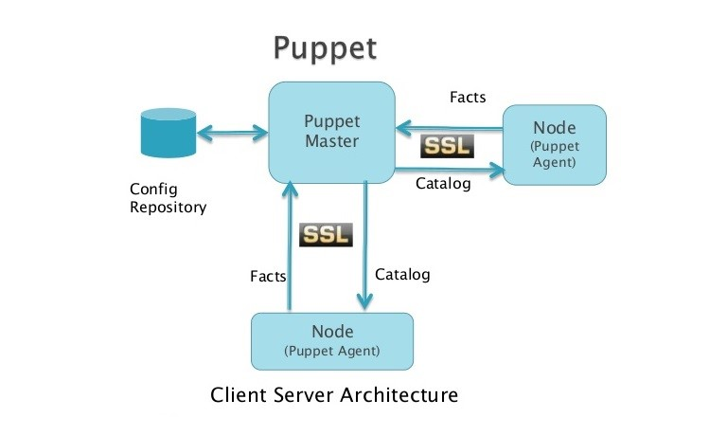

The architecture of Puppet follows a client-server model. Here are the key components of the Puppet architecture explained:

1. **Puppet Master**: This is the main server that controls the configuration of all client nodes. It holds the configuration repository and applies the desired state to nodes. The Puppet Master is responsible for compiling a catalog based on the configuration and facts it receives from the nodes.
2. **Nodes (Puppet Agents):** These are the client machines where the configuration needs to be applied. Each node sends a report of its current state (known as facts) to the Puppet Master, and in return, the Puppet Master sends a catalog to instruct the node how to achieve the desired state.
3. **Config Repository:** This holds the configuration files (also known as manifests) and modules that define the desired state of the system.
4. **Facts:** Facts are key-value pairs about the system, such as IP address, hostname, and operating system, that the node sends to the Puppet Master. This helps the master compile the appropriate catalog for that node.
5. **Catalog**: The catalog is a document that describes the desired state for each resource on a node. The Puppet Master compiles the catalog based on the facts received from the node and sends it back to the node.
6. **Secure SSL Communication**: Both the Puppet Master and the agents communicate using a secure SSL connection. This ensures that the communication between the nodes and the master is encrypted and secure.

**CREATION OF A MASTER INSTANCE ON EC2:**

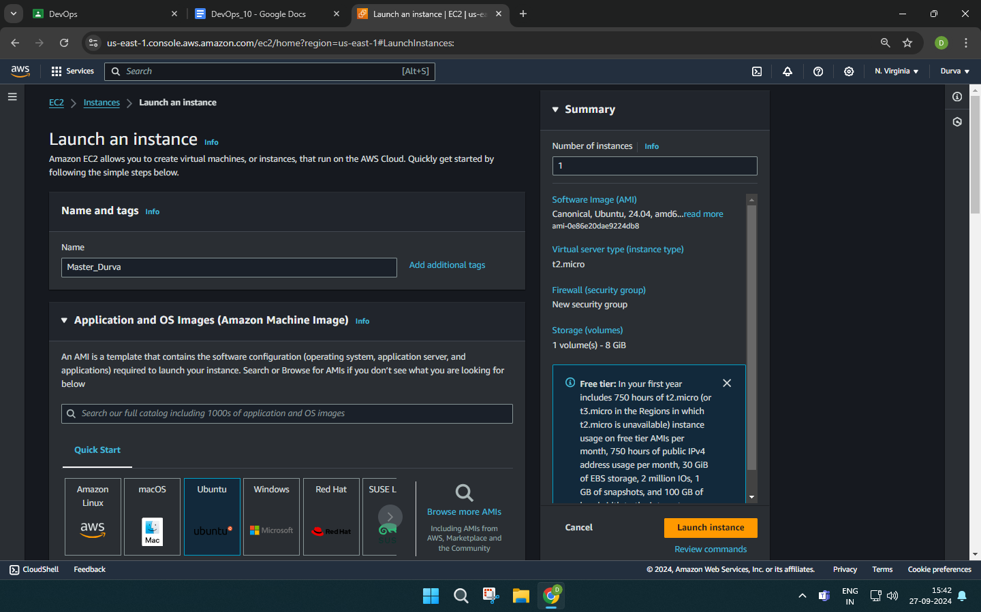

**SUCCESSFULLY CREATED:**

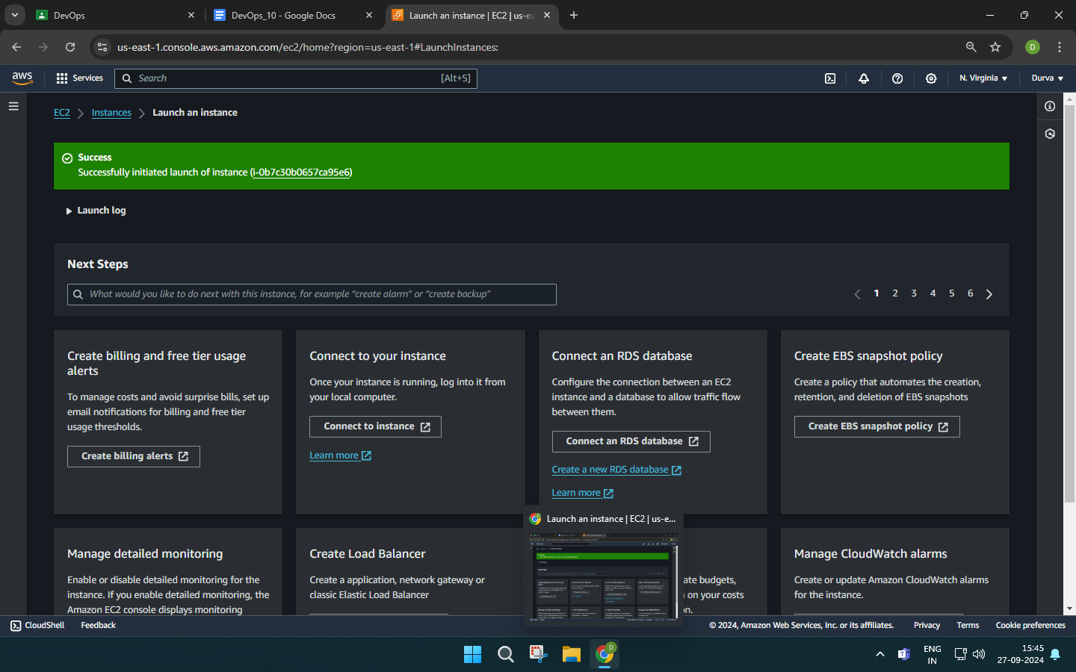

**CREATION OF A SLAVE INSTANCE ON EC2:**

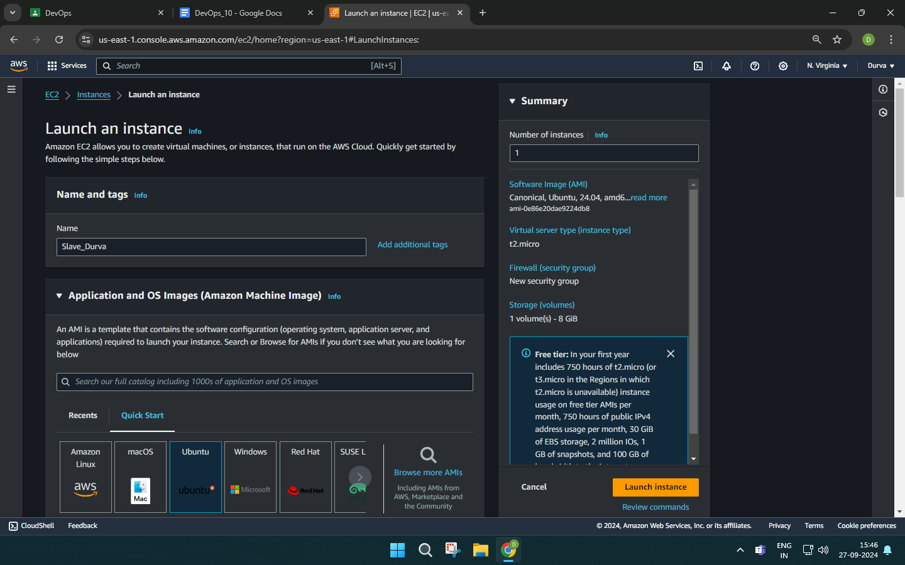

**SUCCESSFULLY CREATED:**

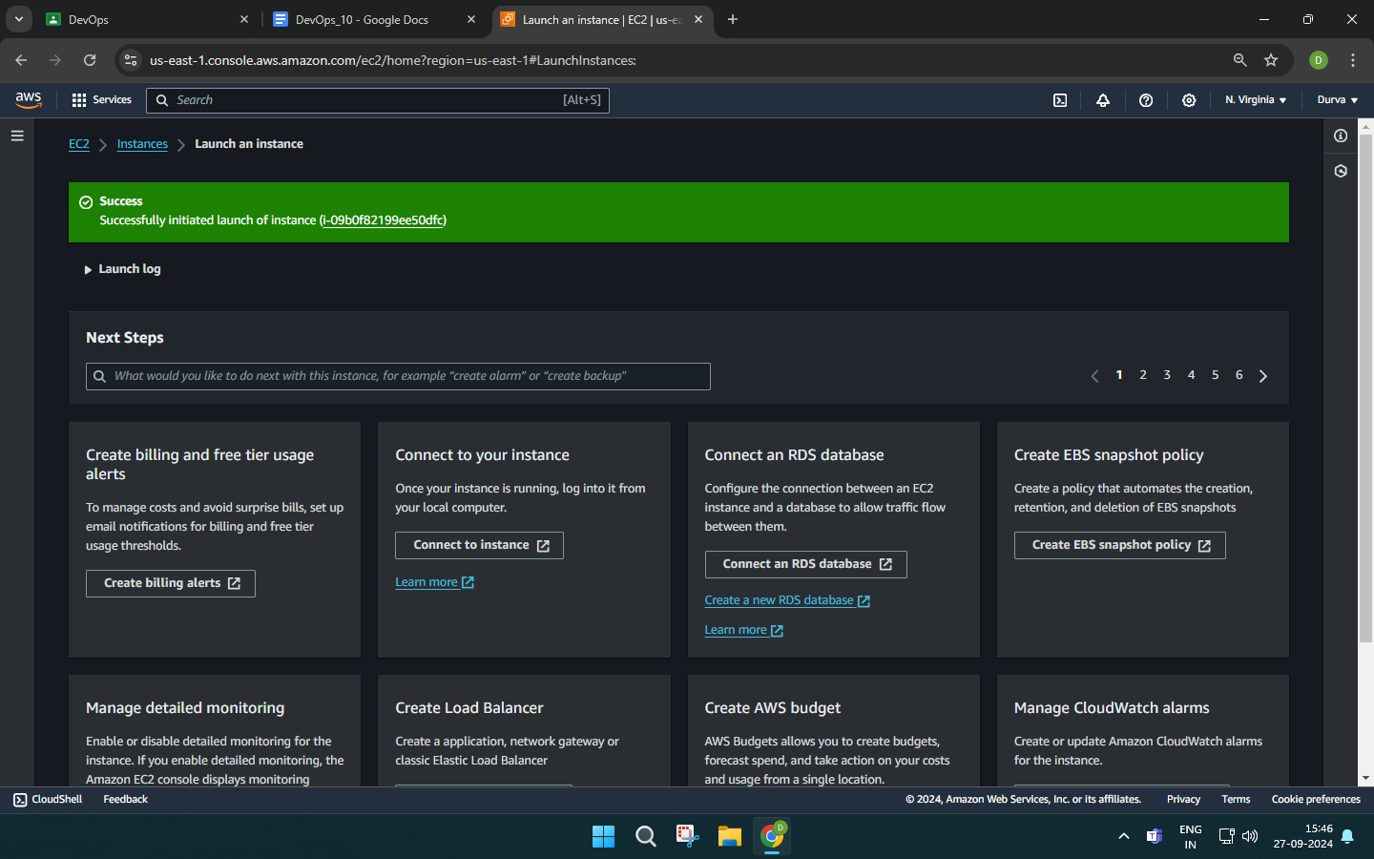

**THE MASTER AND SLAVE INSTANCES ARE RUNNING:**

